|  |  |
| --- | --- |
| **System Request – Surgery on Sunday Louisville** | |
| **Project Sponsor** | Dr. Robert M. Barker and the University of Louisville College of Business |
| **Business Need** | * Decrease overhead of managing donor and volunteer information * Increase donations. * Improve marketing * Increase demographic communications. * Increase flow of information |
| **Business Requirements** | * Include email subscription * Provide links to social media on website * Create database to store donor and volunteer information. * Automate storage of donor and volunteer information to database * Allow webpage to be translated * Improve donor forms * Include more donation options |
| **Business Value** | * Social media links easier to find on website - 10% increase in donations totaling to additional $750.00 per year. * Language translator - 2% increase in friends/family of patients donate totaling to additional $500.00 per year. * Saved time and effectiveness from relational database tied to donor/patient/volunteer forms. 2 additional grants at $5,000 each + 10% increase in donations per year. $10,750.00 |
| **Special Issues or Constraints** | * Needs to be an easy-to-use system * Limited budget * Prefer to implement while still using WordPress if possible * Planning must be done by Dec. 4th (end of the semester) |

**Narrative**

**Problem Statement:**

Surgery on Sunday Louisville is a non-profit organization that provides outpatient surgical and endoscopic procedures to people in need. They are going to need an efficient website that will include best practices and improved business processes that will ultimately lead to significant growth of the organization.

After analyzing SOS Louisville’s business processes, we have found many areas that can be greatly improved to have a substantial impact that will lead to growth of the organization. One of the problems we noticed was their lack of a functional social media link. The link was hard to find and did not work correctly. Another issue we have come across was the inability to translate the webpage from English to Spanish. This is a problem considering 76% of their patients are Spanish speaking. A third area for improvement we have noticed is the lack of functional donor forms. All information from donors currently comes directly from PayPal. Donors are unable to leave any type of message along with the donation. One of the bigger issues is the fact that all their donor information, volunteer information, facility information, staff information is not currently being stored in one central location to where it can interact.

**Expected Solution:**

After looking at a handful of issues and areas that can be improved, here is how we propose to fix it. First, you will want to include links to social media on every page of the website. Whether it is at the bottom or top of each page, it needs to be easily accessed to direct users to your social media pages to get more likes and shares leading to greater awareness. This will bring in more volunteers and donations. Second, a drop-down menu will be added to the top of the webpage that will allow users to toggle between English and Spanish. Since the majority of your patients are Spanish speaking, this will allow their family members to better understand your organization making them more likely to support your cause by donating. Third, donor forms need to be improved, when a donor fills out a form to donate, their information needs to be sent straight to you and stored into a database to avoid any potential oversites, avoid potential errors that comes with manual entry, and to eliminate time waste from manual entry. The same thing goes for volunteers and patients, forms need to automatically add their information into a database. The fourth and biggest improvement that will tie everything together is creating a relational database for all volunteers, patients, facilities, staff, events, etc. This will put all the information into one central location and simple queries can be ran to pull any piece of information that you need making organizing and scheduling events more streamlined saving lots of valuable time.

**Business Case:**

Let’s assume that SOS Louisville’s average donation is currently $50.00 with approximately 150 donors per year totaling to $7500.00 in donations. Also, assume that an average grant is $5000.00 at 5 grants per year for a total of $25000.

The following describes the estimated increase in donations from making social media accessible from every page on the website:

* Pessimistic outcome – 5% increase totaling to an additional $375.00 per year.
* Expected outcome – 10% increase totaling to an additional $750.00 per year.
* Optimistic outcome – 15% increase totaling to an additional $1125.00 per year.

Allowing the website to be translated to Spanish will increase the likeliness of the friends and family members of the Spanish speaking patients to donate. Assuming that surgeries are performed on 50 Spanish speaking patients per year and each patient has 10 friends and family members totaling to 500 you can expect the following:

* Pessimistic outcome – 1% more of friends and family members donate at the average rate totaling to $250.00 more per year.
* Expected outcome – 2% more of friends and family members donate at the average rate totaling to $500.00 more per year.
* Optimistic outcome – 3% more of friends and family members donate at the average rate totaling to $750.00 more per year.

Improving donor forms and automatically storing donor, volunteer, and patient information into a created relational database can save time and allow for more grant writing and communication with donors and volunteers.

* Pessimistic outcome – 1 more grant received per year with a 5% increase in donations totaling to and additional $5375.00 per year
* Expected outcome – 2 more grants received per year with a 10% increase in donations totaling to an additional $10750.00 per year.
* Optimistic outcome – 3 more grants received per year with a 15% increase in donations totaling to an additional $16125.00 per year.

**Technical Feasibility:**

**Familiarity with Functional area**

SOS Consultants have a solid understanding of the current system SOS Louisville is currently working with and will be able to implement a system with minimal risk to perform the same tasks in a more efficient manner.

**Familiarity with Technology**

The technology used should pose minimal risk within the organization and will be easy to use.

Learning basic functions of the new database will be the only risk involved.

**Project Size**

With this being a smaller project that is estimated to take 3-5 months and no major system requirements, the risk should be very minimal.

**Compatibility**

There should be no compatibility issues. The database created will be built from scratch and will only require data entry from existing spreadsheets to populate database with existing information.

**Economic Feasibility:**

|  |  |
| --- | --- |
| **Development Costs** | |
| DBMS License | $0 |
| Server | $750.00 |
| **Annual Operating Costs** | |
| CMS Fee | $0.00 |
| PS Fee | $0.00 |
| **Annual Benefits** | |
| Social media easier to find on website | 750.00 (10% increase in donations) |
| Language Translator | 500.00 (2% increase in donations from patient friends and family members) |
| Relational Database with Improved Forms/Automation | 10750.00 (10% increase in donations + 2 additional grants) |
| **Intangible Benefits and Costs** | |
| Increase in volunteers |  |
| Greater organizational awareness |  |

**Organizational Feasibility:**

* **Project Champion -** Erica Sutton and Barbara Martin
* **Senior Management -** Erica Sutton and Barbara Martin
* **Users -** SOS Louisville Staff
* **Other Stakeholders -** Donors, volunteers, Facilities, and Patients

The project is strategically aligned with the business because with the improvements to their business processes it will allow them to operate more efficiently and establish a solid foundation that will allow them to keep up with their goal of organizational growth. This means that if they were to double or triple in size, the amount of overhead from the improved processes will be minimal as opposed to their current processes.

**Process Models**

**“As-is” Process Model:**

Currently, Surgery on Sunday Louisville’s process for taking in donor, volunteer, and patient information and turning this into events, newsletters, and stories is convoluted and extremely manual driven. The donor information gets logged into a Google Suite Spreadsheet via a form filled out on the website. All volunteer and patient information is stored after receiving an email. They must then manually input all information into a spreadsheet by hand which is a long process, depending on the volunteer or patient. When they create events, they must search through these many records to find common links which is a slow process. What SOS Consultants propose is a change in the system completely that will allow for a more streamlined process which would free up time for other tasks within the organization.

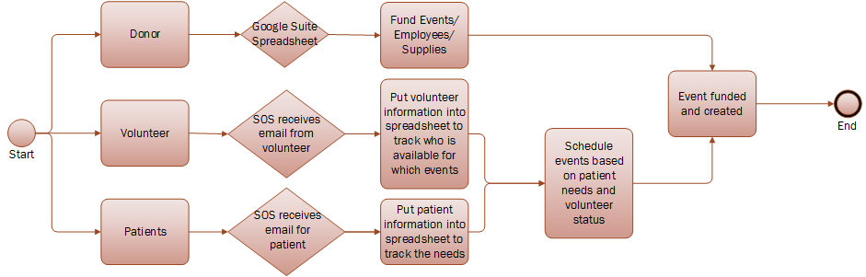

**“To-be” Process Model:**

As stated in the solution, we propose to create a relational database to streamline the process for storing volunteers, donors, patients, facilities, and staff, manage this content easily, and create events based off the information and needs of the patients. We will create forms to allow users to input all the information so it gets stored automatically from the website to the database. From here, SOS Louisville can run queries to pull all information related to a certain event. For example, if they would like to pull all patients in need of colonoscopies and all volunteers who can and/or have performed colonoscopies, it would be easy to do so.

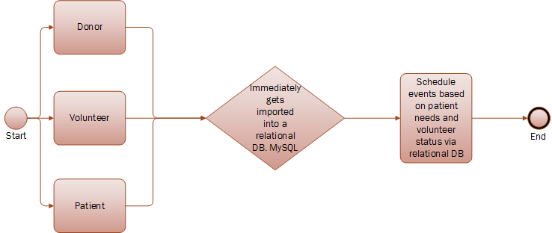

**Agile Stories**

**ID: 1**

Title: Database

As a: User

I want to: Create a database to store donor and volunteer information and automate storage of that information.

So that: More time can be saved instead of manually entering information and keeps volunteer and donor information organized. This can help keep track of donor and volunteer information such as hours worked, the types of volunteers working, etc.

**ID: 2**

Title: Comments

As a: Donor/Patients

I want to: To be able to leave a comment on a forum.

So that: This gives donors and patients a chance to express how they feel after a donation or surgery. Which gives good feedback to Surgery on Sunday that can be seen by website visitors.

**ID: 3**

Title: Social Media

As a: Web User

I want to: See more links for different social media platforms on the website.

So that: More users can see a visual representation of Surgery on Sunday. Also, this will help strengthen the social media presence of the organization.

**ID: 4**

Title: Translation

As a:  Web User

I want to: See the web page translated into Spanish.

So that: More users can understand the website which can also reach out to a broader audience.

**Team Charter**

**Team goals:**

**This semester our team wishes to…**

* Solve SOS’s main problem of organizing their volunteer and donor databases
* Surgery on Sunday to implement our new system
* Work as a unit to complete every assignment and iteration on time
* Improve our presentation and persuasion skills
* Communicate efficiently within our group
* Hold every member accountable for his/her parts
* To communicate efficiently with our client and professor
* Present ourselves professionally to our client and classmates
* Build a relationship and establish rapport with our client

**Team meetings:**

Our team meets twice a week in the classroom, during this time we will discuss upcoming assignments, due dates, and meetings. In addition, to this face-to-face discussion we communicate through GroupMe (a group messaging app). This app allows us to communicate anytime and anywhere. Whether it be face-to-face or through GroupMe, meetings are conducted in order to accomplish a task at hand, this could be anywhere from working on an assignment, working on an iteration, creating a presentation, or preparing to present a presentation. The decisions made regarding meetings, assignments, iterations, etc. are made as a group, meaning everyone has the opportunity to add input. For presentations, we have worked to accommodate each member’s schedule. Before a presentation, we plan to meet twice to go over the agenda, and flow of information during the time of presentation.

**Team communications:**

As mentioned above, as a group we can communicate in one of two ways (face-to-face or GroupMe). However, in regards of material, we have enabled a shared folder in google drive that allows us all to view and/or edit the work done as a group or even the work done in pairs anytime and anywhere. These platforms of communication allow us to communicate ideas, technical material, and make decisions among members. Google drive also allows us to view what others have edited and contributed. It provides an efficient method of collaboration.

To communicate with the client or instructor we take a different approach. This communication should not be done as a group; we do not want to be asking the same person the same question six times. This is where a liaison is selected. This liaison will act as the channel of communication between the group and the client or the group and the professor. The liaison is selected on a volunteer basis. Next, the liaison will contact the client or professor through email and once they receive response it is their responsibility to inform the rest of the group. This information can be relayed through GroupMe or face-to-face.  
**Team decisions:**

Team decisions are typically made face-to-face during the allotted time in class, while ideas are fresh. Throughout the week, our team stays in continuous contact to keep each member accountable. We did not appoint a captain or leader, so we take on all assignments and iterations equally. Any questions or concerns can be relayed through our main communication platform, GroupMe. Here, the whole team can see a member's question, and we can get it solved within an appropriate time period. This is helpful because we can catch any errors or clear confusions and the whole team can come to a consensus.

**Project repository:**

With everyone having their own schedules, we have enabled a shared folder in Google drive that allows us all to view and/or edit the work done as a group or even the work done in pairs anytime and anywhere. Within this shared folder, we have created subfolders that organizes upcoming assignments for collaboration. When something specific is changed or updated, a team member messages everyone in GroupMe to notify every one of the change. By using this internet based solution, we can collaborate more efficiently, see live updates of assignments, and save work instantly to the shared platform.